Get Your Dumpling Fix with This Easy Peking Ravioli Recipe

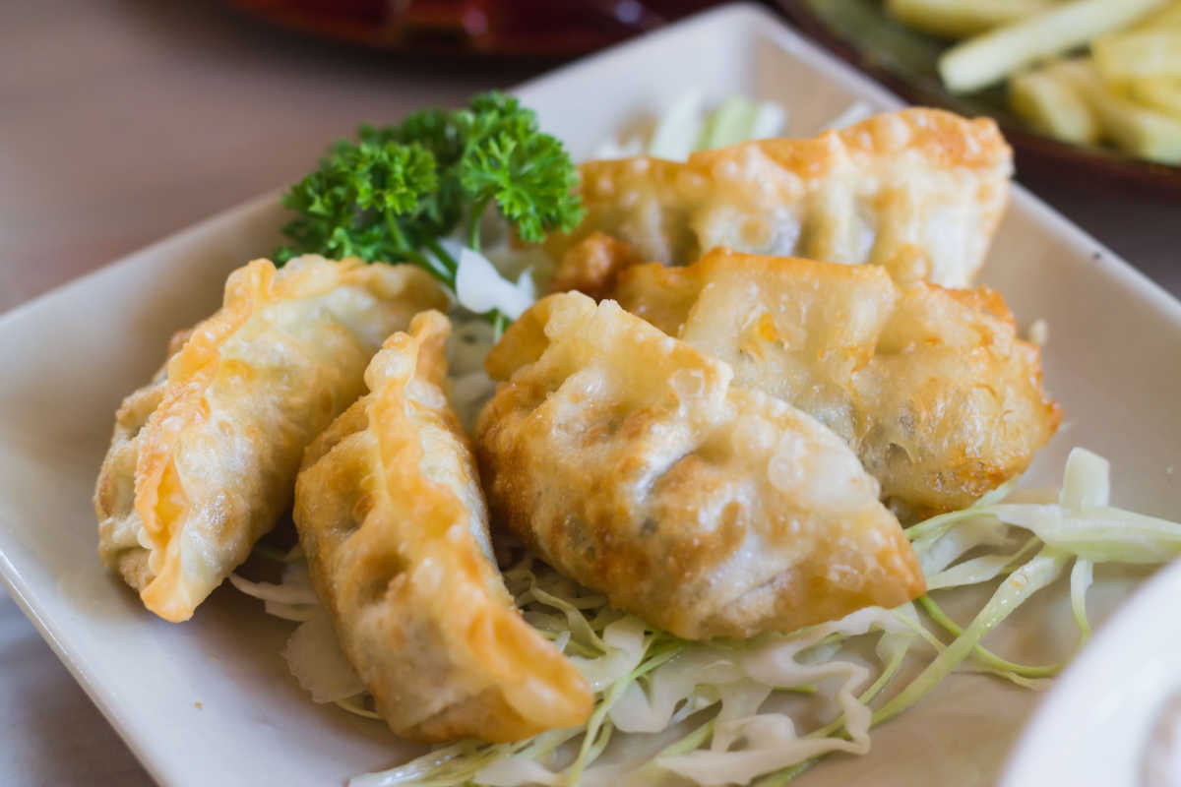

Peking Ravioli, a distinctive syanthesis of Chinese and Western culinary designs, has captured the bears of food lovers worldwide. Originating in Boston's Chinatown in the 1950s, that National accept the original Chinese dumpling is favorite for its crispy, pan-fried layer and savory filling. Unlike old-fashioned ravioli, Peking Ravioli combines tastes and cooking methods to create a yummy appetizer or principal dish. In this extensive information, we'll jump into all you need to know about creating and enjoying Peking Ravioli in the home, from the components to essential cooking techniques.  
  
What is Peking Ravioli? A Brief History  
Peking Ravioli may appear like an Italian-Chinese [peking ravioli recipe](https://delishglobe.com/recipe/spanish-chanfaina-lamb-stew/) hybrid, but its name comes from Boston, Massachusetts. In the 1950s, a cook called Joyce Chen presented the dish to American diners, naming it "Peking Ravioli" to link social knowledge of conventional dumplings. Chen popularized it in her restaurant, wherever it became an area sensation, and her accept dumplings spread around the world, maintaining its distinctive name. As the title "ravioli" refers to Italian pasta, the particular dish is a traditional dumpling, pan-fried to perfection.  
  
Why Peking Ravioli Stands Out Among Dumplings  
Unlike different Asian dumplings, Peking Ravioli has a distinctive perspective: it's frequently larger than normal dumplings and includes a clearer, golden-brown outside from pan-frying. The filling is really a savory mix of floor pig, veggies, and seasonings, offering each mouthful a healthy profile. The dumpling wrapper becomes soft on a single side and crispy on another, developing a gratifying distinction in texture. That harmony of taste and texture makes Peking Ravioli a crowd-pleaser and a delicious plate value trying.  
  
Ingredients You'll Need for Authentic Peking Ravioli  
To create Peking Ravioli, you'll need fresh, quality ingredients. Under is really a break down of the fundamental ingredients and how they donate to the dish's quality:  
  
Floor Pork: The traditional stuffing for Peking Ravioli is soil pig, supplying a savory and succulent flavor. Use supreme quality pork with a bit of fat for extra flavor.  
Cabbage: Cabbage adds meltdown and water to the filling. Napa cabbage or natural cabbage work well, perfectly chopped and lightly salted release a excess water.  
Green Onions: Provides moderate onion quality and freshness.  
Garlic: Essential for depth, minced garlic provides a refined kick to the filling.  
Soy Sauce: Provides umami and saltiness. Use a top quality soy sauce for a balanced taste.  
Ginger: New cinnamon delivers heat and a little tart, increasing the pork flavor.  
Sesame Gas: Adds a ridiculous aroma and richness.  
Dumpling Wrappers: While making wrappers from scratch is a choice, store-bought dumpling wrappers work well and save your self time. Search for heavier wrappers to put up around frying.  
Optional Ingredients for Enhanced Flavor  
Asian Rice Wine or Shaoxing Wine: Adds some acid and difficulty to the filling.  
Dark Pepper or Bright Pepper: A touch of pepper can increase the entire seasoning.  
Soup Flakes or Sichuan Peppercorns: For people who enjoy tart, a little heat raises the quality profile.  
Step-by-Step Recipe for Homemade Peking Ravioli  
1. Prepare the Filling  
Salt the Cabbage: Place the finely sliced cabbage in a pan, spread it with sodium, and allow it stay for 15-20 minutes. Press out any surplus water to stop sogginess.  
Combine Components: In a pairing bowl, mix the ground pig, drained cabbage, green onions, minced garlic, soy sauce, sesame gas, ginger, and optional seasonings. Mix carefully until the filling is well-blended.  
Test the Quality: For perfect seasoning, make a little bit of completing a pot and change the sodium or soy sauce as needed.  
2. Assemble the Dumplings  
Prepare the Wrappers: Place a dumpling wrapper on a clean surface. Soak your hand in water and moisten the edges of the wrapper to simply help it seal.  
Add Filling: Scoop a little bit of filling into the biggest market of the wrapper, being cautious to not overfill.  
Close the Dumplings: Fold the wrapper in two to form a half-moon shape. Press the edges firmly to close, making certain no air is stuck inside. Pinch pleats across the edge for a normal search and a tighter seal.  
3. Pan-Fry the Dumplings  
Temperature the Container: Put in a thin coating of fat to a non-stick or cast-iron skillet and heat over medium-high.  
Place Dumplings in the Container: Organize the dumplings in a single layer, with a little bit of room between each.  
Fry Till Wonderful: Cook for approximately 2-3 minutes before bottoms are wonderful brown.  
Steam to Prepare Through: Carefully include about ¼ pot of water to the pot and cover immediately. Permit the dumplings to water for 5-7 moments before water evaporates.  
Clean the Base: Take away the lid and continue cooking before the lows are crispy again, about 1-2 minutes.  
4. Serve the Peking Ravioli  
Move the crispy dumplings to a helping plate. Offer hot with a side of soy sauce, vinegar, or your chosen dipping sauce.  
  
Crafting the Perfect Dipping Sauce  
A great dipping sauce is the key to elevating the taste of Peking Ravioli. Here's a simple however tasty formula for a balanced dropping sauce:  
  
Soy Sauce (3 tbsp): Forms the foot of the sauce with savory, salty flavor.  
Rice Vinegar (1 tbsp): Provides acid and amounts the saltiness of soy.  
Sesame Oil (1 tsp): Brings an abundant, mad aroma.  
Garlic (1 clove, minced): Adds pungency and depth.  
Green Onions (1 tbsp, chopped): For shade and new flavor.  
Optional Soup Flakes or Paste: For a hint of spice.  
Combine these components in a tiny bowl, mixing until well mixed. Regulate the ingredients centered on your own style preference.  
  
Tips for Perfecting Your Peking Ravioli  
Use Cool Water for Dough: If making wrappers from damage, cold water assists produce a chewy texture.  
Prevent Overfilling: An excessive amount of filling helps it be difficult to seal and can lead to breaks while cooking.  
Test Your Seasoning: Cooking a little bit of stuffing first can help you regulate seasoning.  
Use a Non-Stick or Cast Iron Pan: These pans distribute heat evenly for crispier dumplings.  
Be Cautious with Water: When adding water for steaming, make use of a bit in order to avoid splattering, and protect instantly to capture steam.  
Health Benefits of Peking Ravioli Ingredients  
Peking Ravioli is not merely tasty but also incorporates components with health benefits:  
  
Pig: A great supply of protein and important T supplements, contributing to muscle wellness and energy.  
Cabbage: Saturated in vitamins D and E, promoting resistant health and bone strength.  
Garlic and Cinnamon: Equally known for anti-inflammatory and antioxidant attributes, promoting heart wellness and digestion.  
Natural Onions: Low-calorie and full of fiber, supplements, and minerals.  
FAQs About Peking Ravioli  
Can I Produce Peking Ravioli Ahead of Time?  
Sure! You can make and freeze the dumplings before cooking. Position the assembled dumplings on a baking page and freeze for a couple hours before transferring them to an airtight container. When you're prepared to make, you are able to cook them straight from freezing, putting an extra second to the preparing time.  
  
Are There Veggie Choices for Peking Ravioli?  
Absolutely. Exchange ground chicken with a blend of mushrooms, tofu, and perfectly chopped vegetables such as peas, cabbage, and onions. Add a splash of soy sauce and sesame fat for extra flavor.  
  
What May I Offer with Peking Ravioli?  
Peking Ravioli sets effectively with light, fresh sides like cucumber salad, pickled veggies, or miso soup. The crispy, savory dumplings comparison superbly with refreshing side dishes.  
  
Why Peking Ravioli Deserves a Spot in Your Recipe Collection  
Peking Ravioli is a delicious plate that brings together the best of Chinese culinary tradition and National creativity. Using its crispy exterior, succulent stuffing, and bold types, it's a adaptable bowl that performs being an appetizer, snack, or major course. Whether you are a supporter of dumplings or new to Asian cuisine, Peking Ravioli offers a pleasant culinary experience. From building the right stuffing to pan-frying, these dumplings give a fun preparing experience with a satisfying prize at the end.